## Lab 3-02: Object Versioning

### Lab Prerequisites

* Familiarity with basic Google Cloud Computing concepts and terminology.
* A Google account with an active subscription.

### Service Introduction

Google Cloud Platform (GCP) Object Versioning is a feature that allows you to store and manage multiple versions of an object in a GCP storage bucket. When you upload a new version of an object with the same name as an existing object, GCP automatically creates a new version of the object and retains the older version(s) in the bucket. This allows you to track changes to objects over time, recover previous versions of objects, and prevent accidental deletions or overwrites.

Object versioning in GCP also provides protection against data loss caused by human error, malicious attacks, or system failures. You can set retention policies for object versions to prevent them from being deleted before a certain time-period, and you can also use lifecycle management to automatically delete older versions of objects based on the rules you specify.

### Case Study AI Image Generator – Imageprod

Background

Imageprod. is a website that allows users to create images from text using a simple interface. Users can enter text and choose from a variety of design templates to create images with custom fonts, colors, and graphics. The website uses Google Cloud Platform (GCP) for storing the images created by users.

GCP cloud storage is used by Imageprod to store the images created by users securely and reliably. The images are stored in GCP buckets, which are highly durable and scalable storage containers that can handle large amounts of data. Imageprod also uses GCP for other cloud services such as authentication and access control, which helps ensure user data security.

The use of GCP cloud storage allows Imageprod to provide a fast and responsive service to users, with quick image rendering times and reliable storage of the resulting images. This makes Imageprod a convenient and user-friendly tool for creating images from text without the need for advanced design skills or software.

### Business Challenge

Their ML model is still in the training phase. The images created by the model need to be reviewed by the developers to ensure that the model is working as intended. Therefore, they are looking for a storage option to store these images along with the text. The images need to be kept for 1-3 months or until a developer has reviewed and manually deleted them.

### Proposed Solution

You have been hired to present a solution for this challenge. You, as a Cloud Architect, have suggested the use of object versioning. Either nearline, coldline, or archive can be used according to the preference.

Lab Diagram

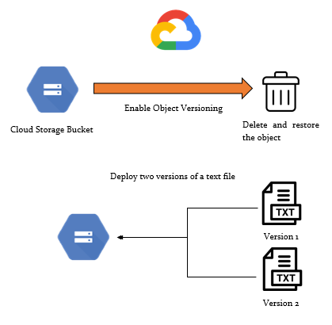

Figure 3-03: Lab diagram

Implementation Steps

1. Enable the versioning status of the bucket.
2. Delete and restore the object in the bucket.

Solution

**Scenario:**

A company wants to keep the archived versions of the objects in GCS. It also wants to delete the oldest version after its required duration. How will this be done?

**Solution:**

By using object versioning and object lifecycle management in GCS, these requirements can be fulfilled.

1. Go to the GCS where your bucket exists. Open Cloud Shell by clicking on “Activate Cloud Shell” and type the command “gsutil versioning get gs://<bucektname>” to check the versioning status of the suspended bucket.

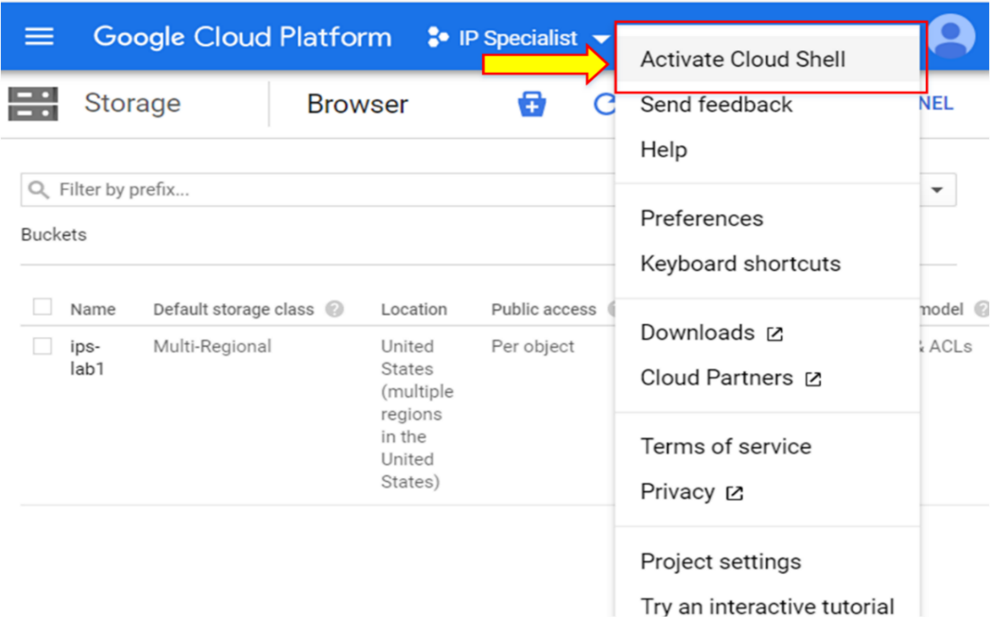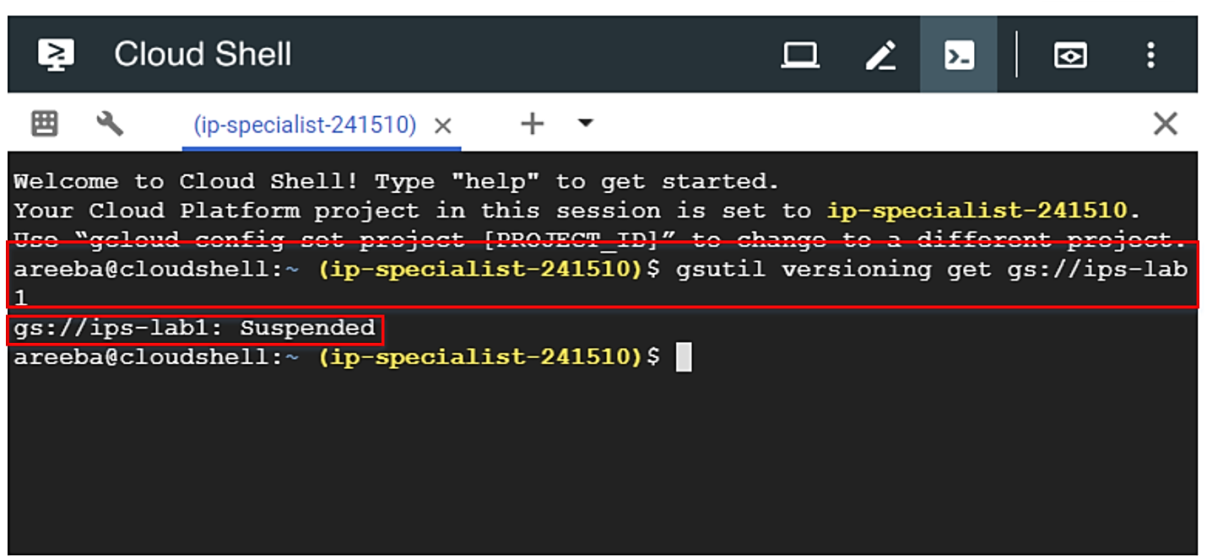

1. To enable the versioning inside the bucket, type the command “gsutil versioning set on gs://<bucektname>”. After that, check the policy again.

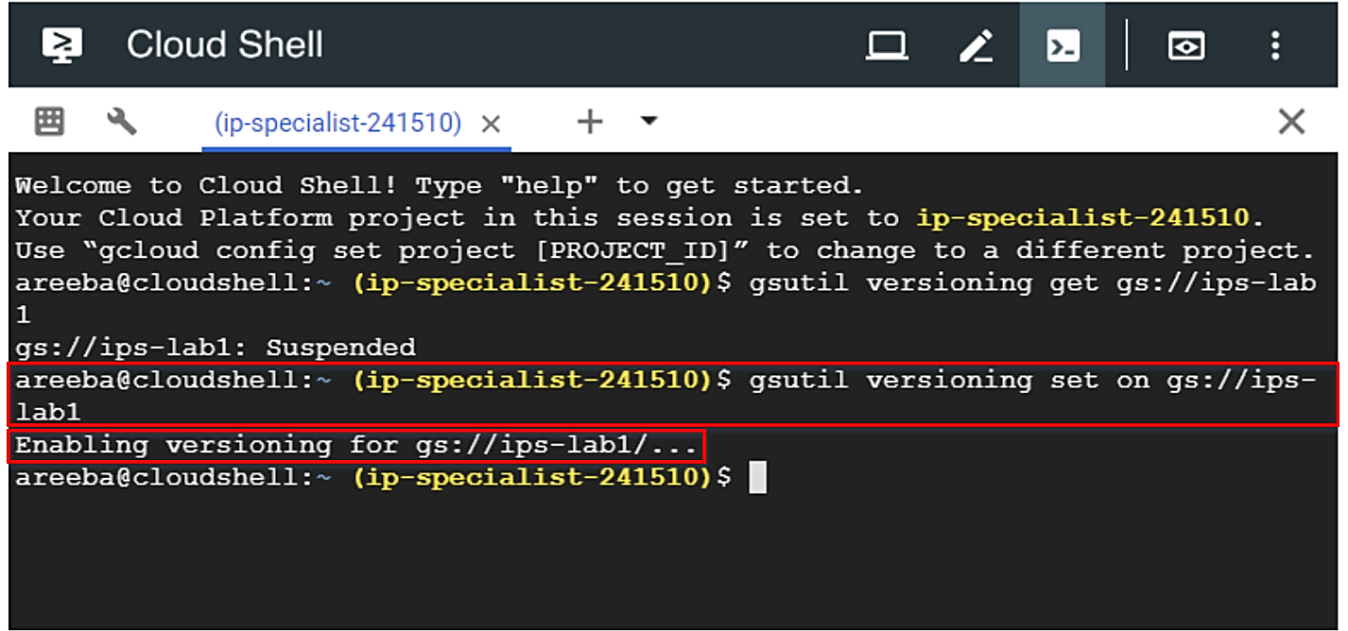

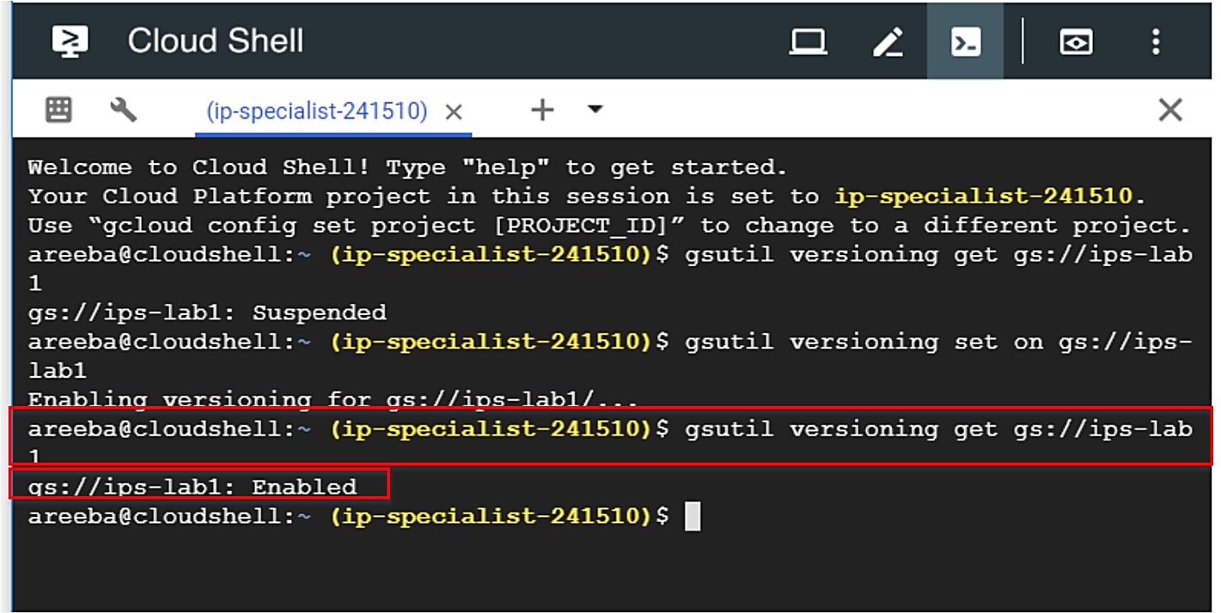

1. Now, delete the file from the bucket via console.

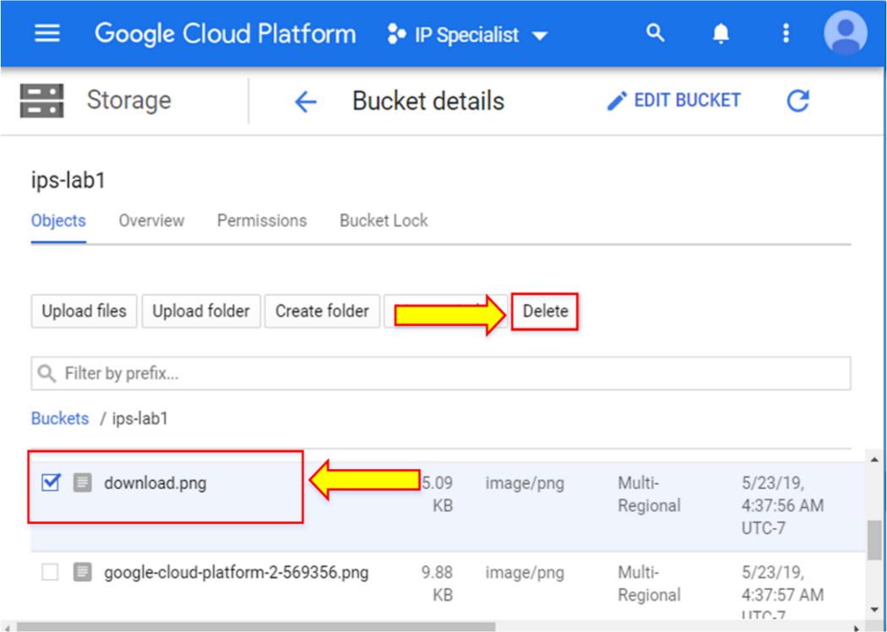

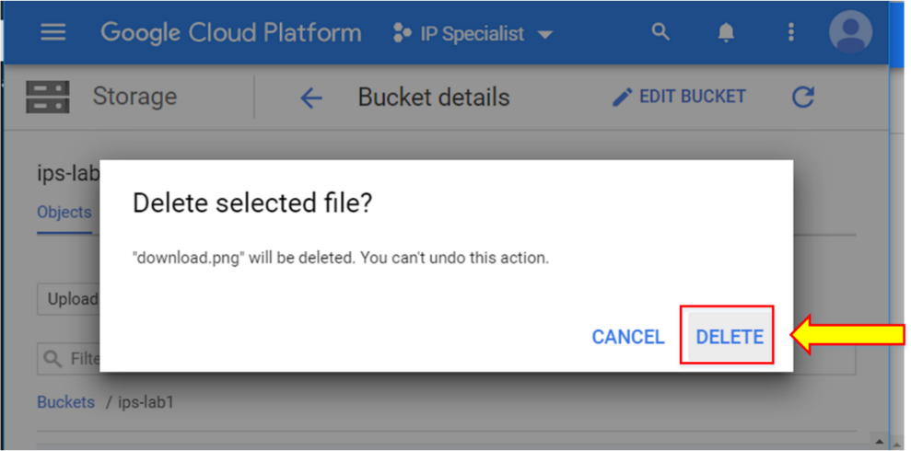

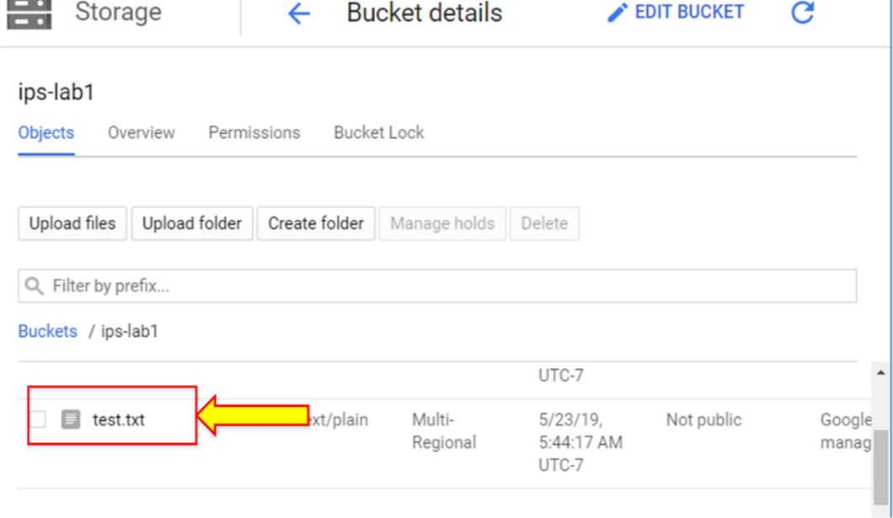

1. Go to Cloud Shell to see the archived objects of the bucket from Cloud Shell. Type the command “gsutil ls –a gs://<bucketname>”. The file with the generation number will be shown, and when you type the command “gsutil ls gs://<bucketname>”, it will show no file, as you have previously deleted it from the GCS.

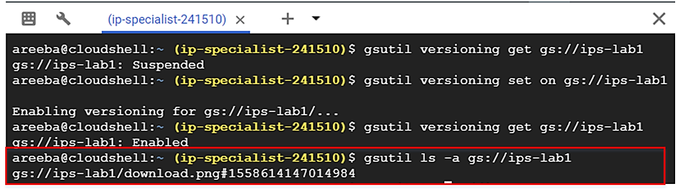

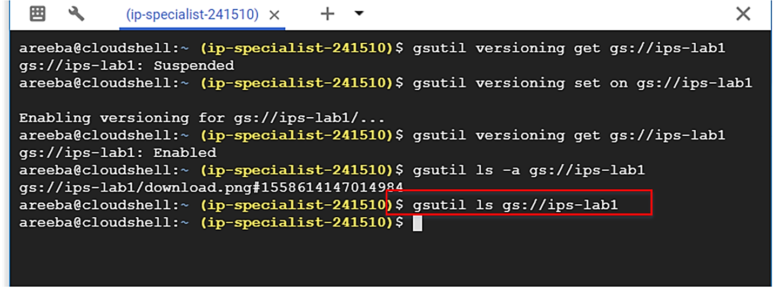

1. To make this archived object a live object again, you can use the command “cp” or “mv”; either one will make this file a live object again. Type the command “gsutil mv <source> <destination>”. With the “mv” command, you will see that the generation number of the object has changed, it has become live again and the archived version of the object has been removed.

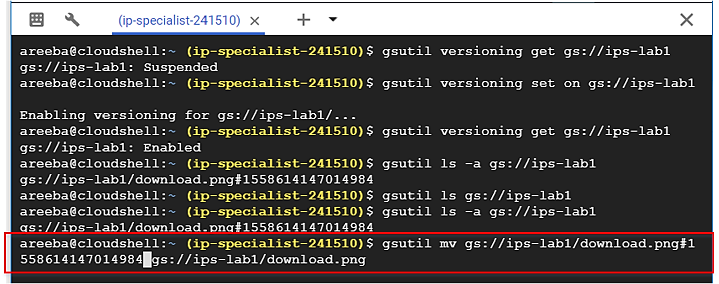

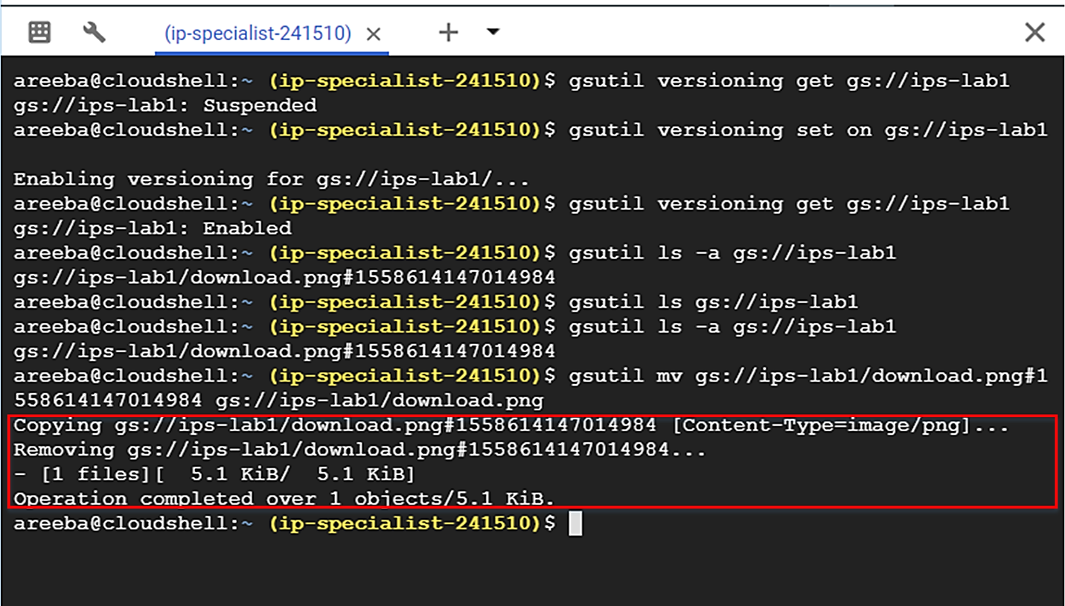

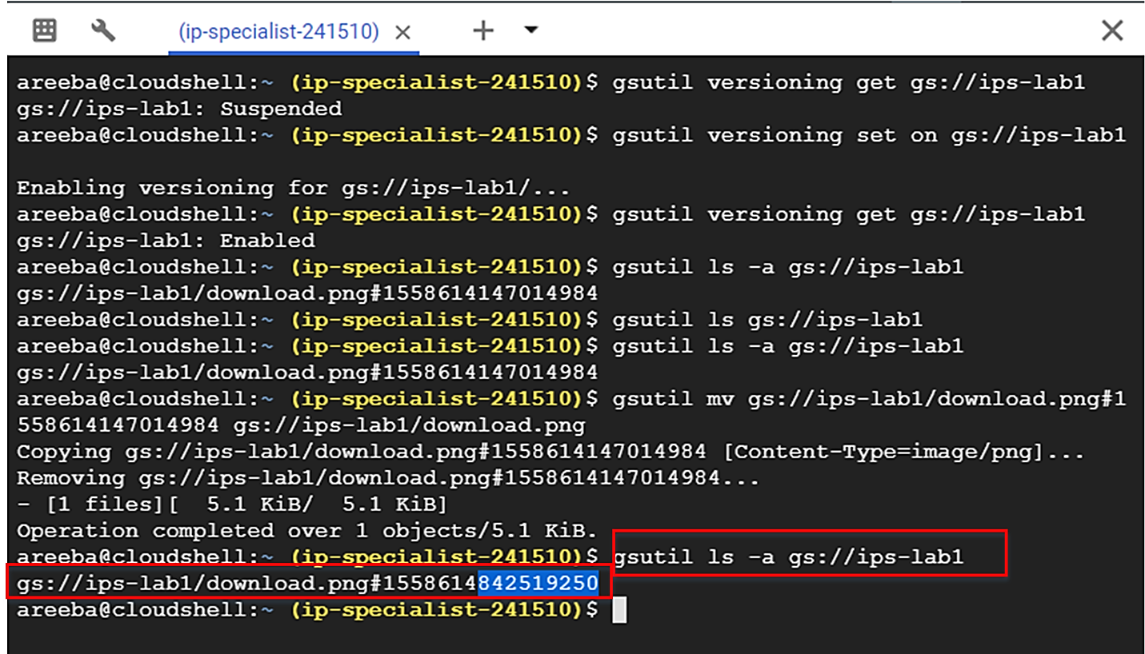

1. If you perform the above step with the “cp” command, you will see a detailed view of the bucket. It will show you two files, one is the live version and the other is archived.
2. Let’s create a text file and copy the file with different versions. Follow the steps shown in the following figure to create a text file.

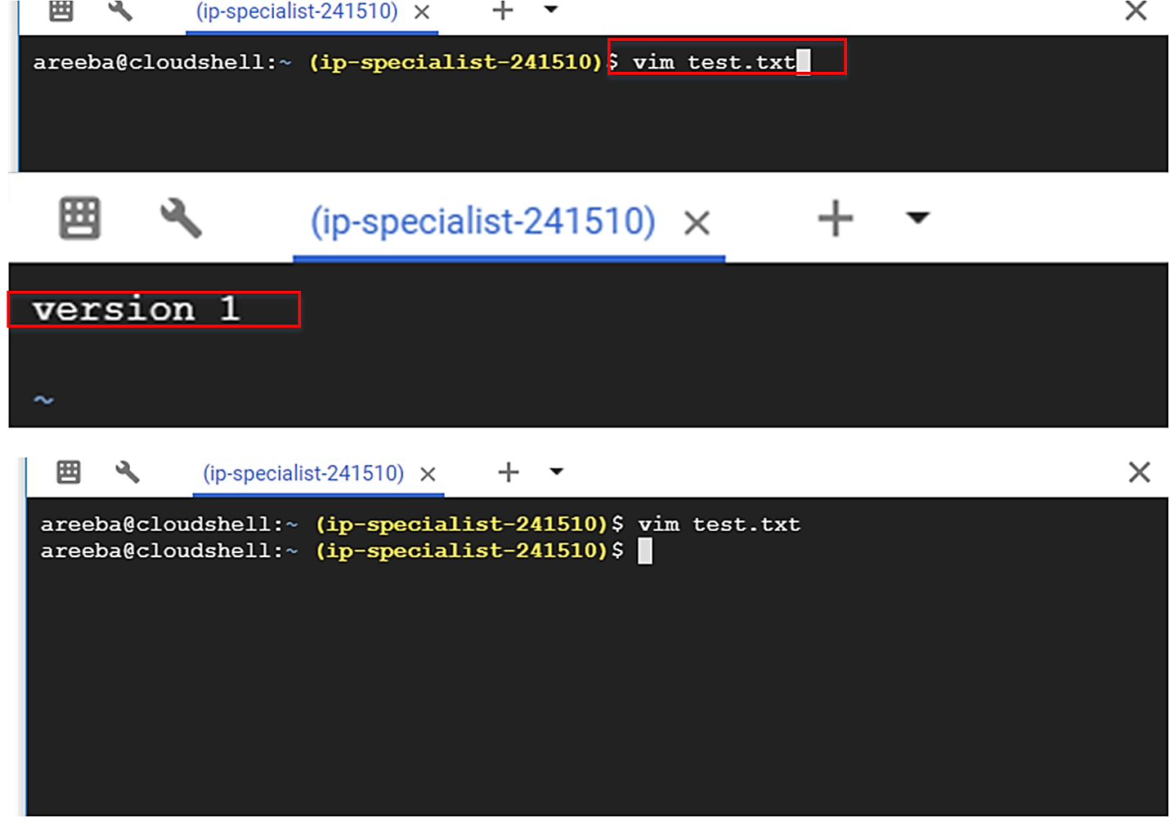





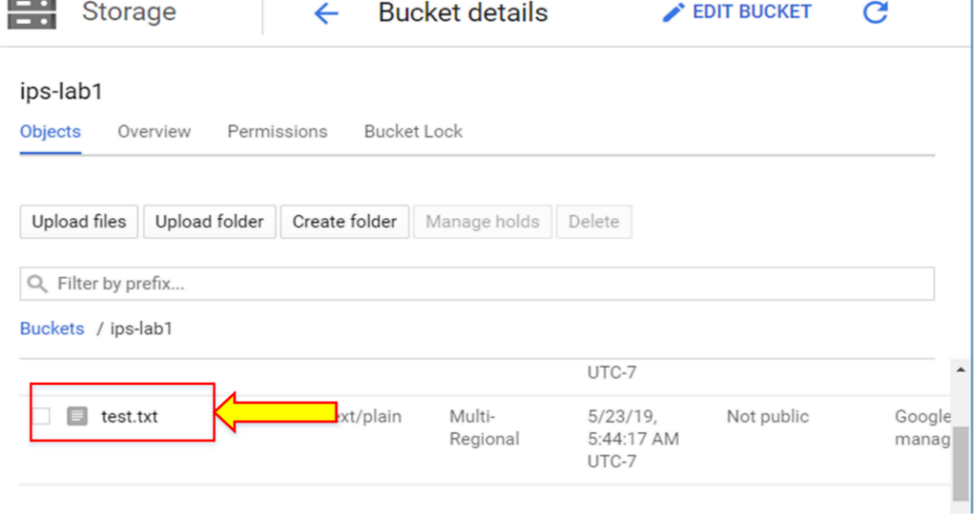

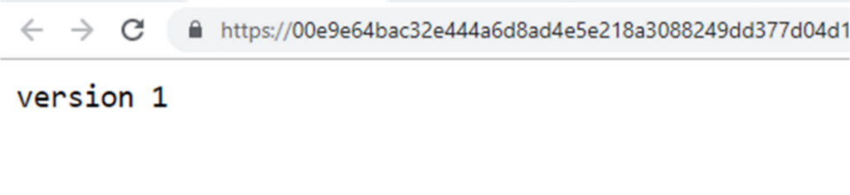

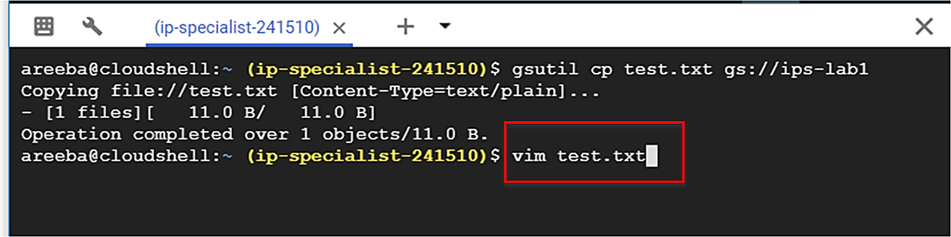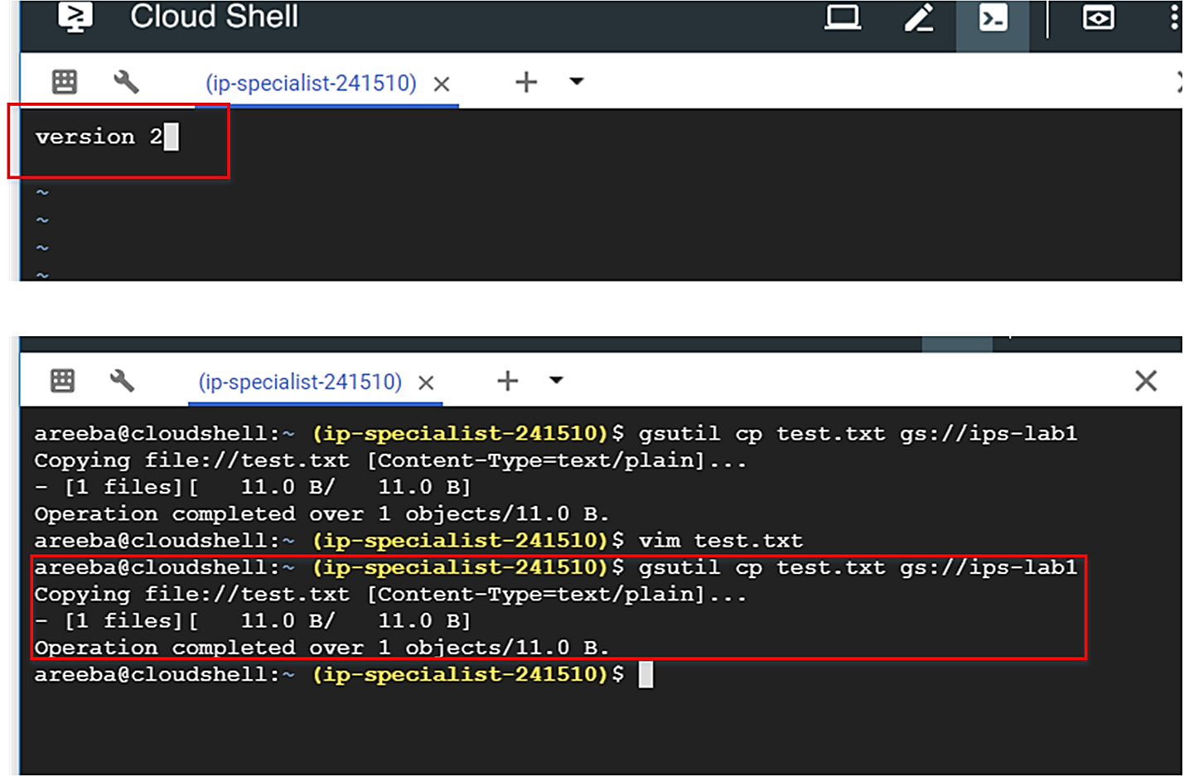



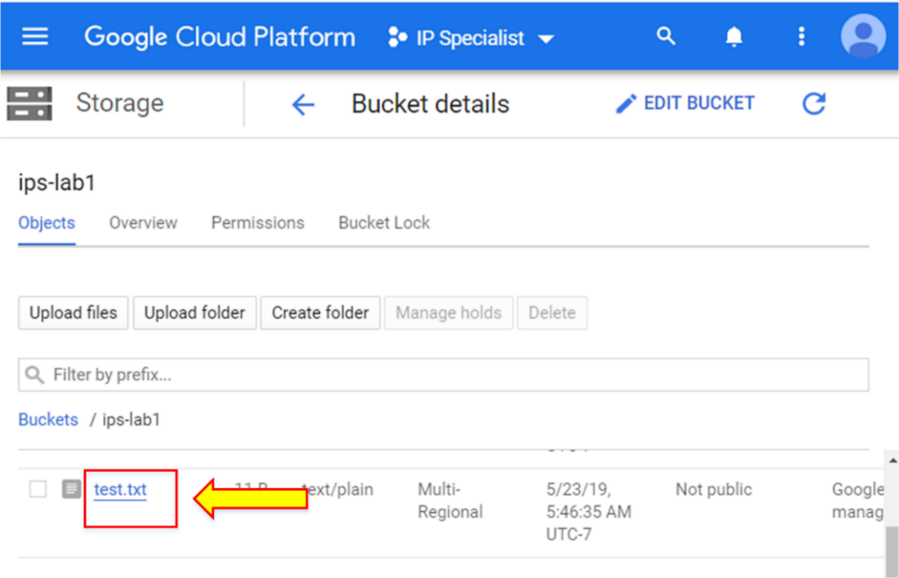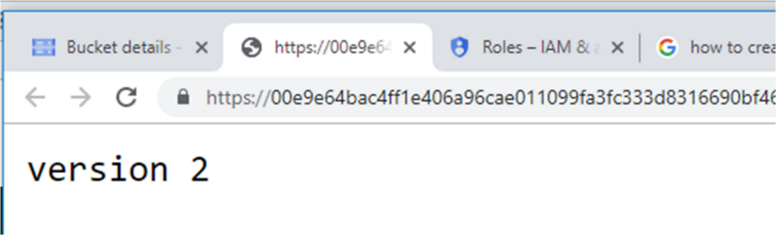

1. Now, check the detailed view of the bucket by typing the command “gsutil ls –a gs://<bucketname>”. Here, you can see all versions of the text file, which overwrite the live versions. The live version is also visible. You will see that the generation number of the newer version is higher than the previous version.

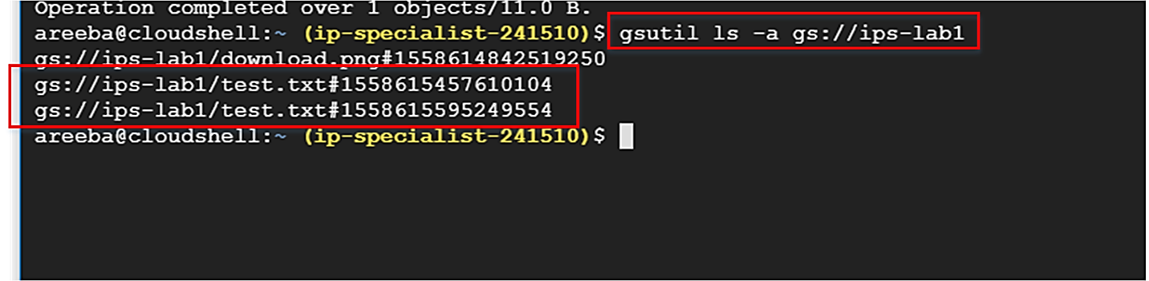

1. To see only the live version of an object, type the command “gsutil ls gs://<bucketname>”.

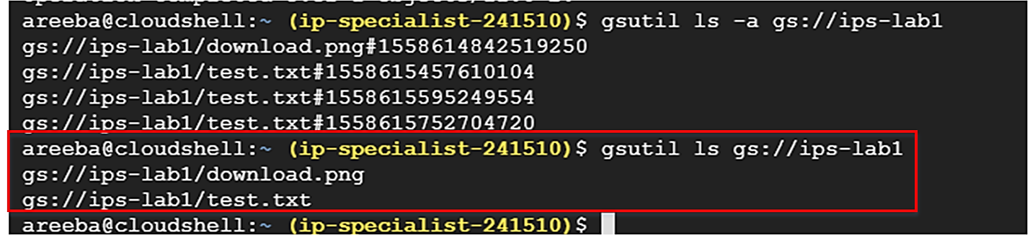

1. Now, if you want to save only the limited number of archived versions, then you need to define the object lifecycle policy via console. Go to the bucket and click on “None” in lifecycle.

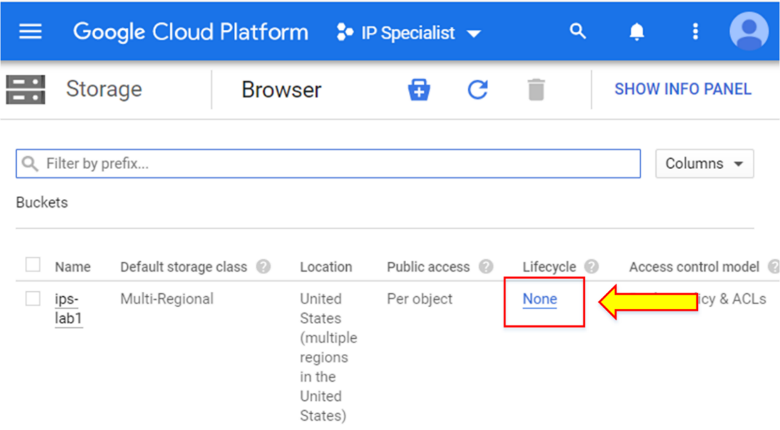

1. Click “Add rule”.

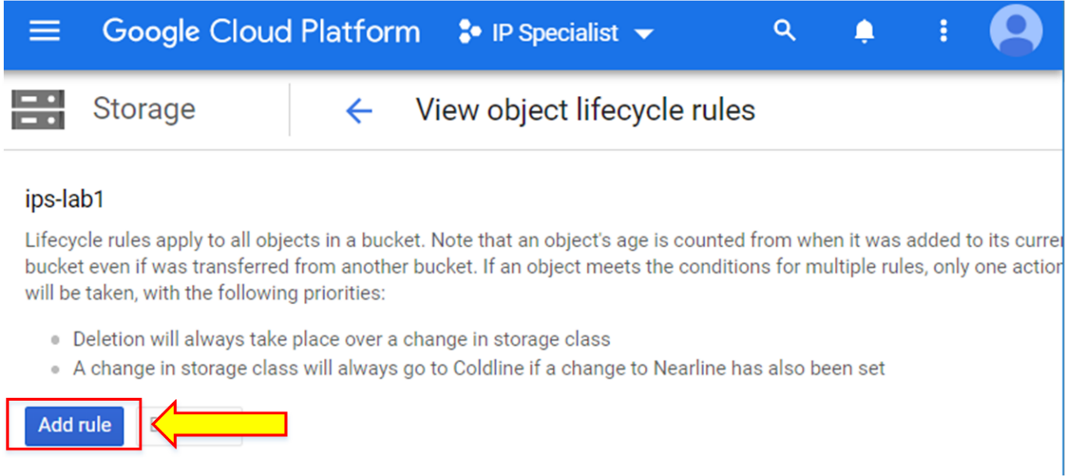

1. Select the desired conditions. Here we used the “Newer versions” and “Age” conditions. Click “Continue”.

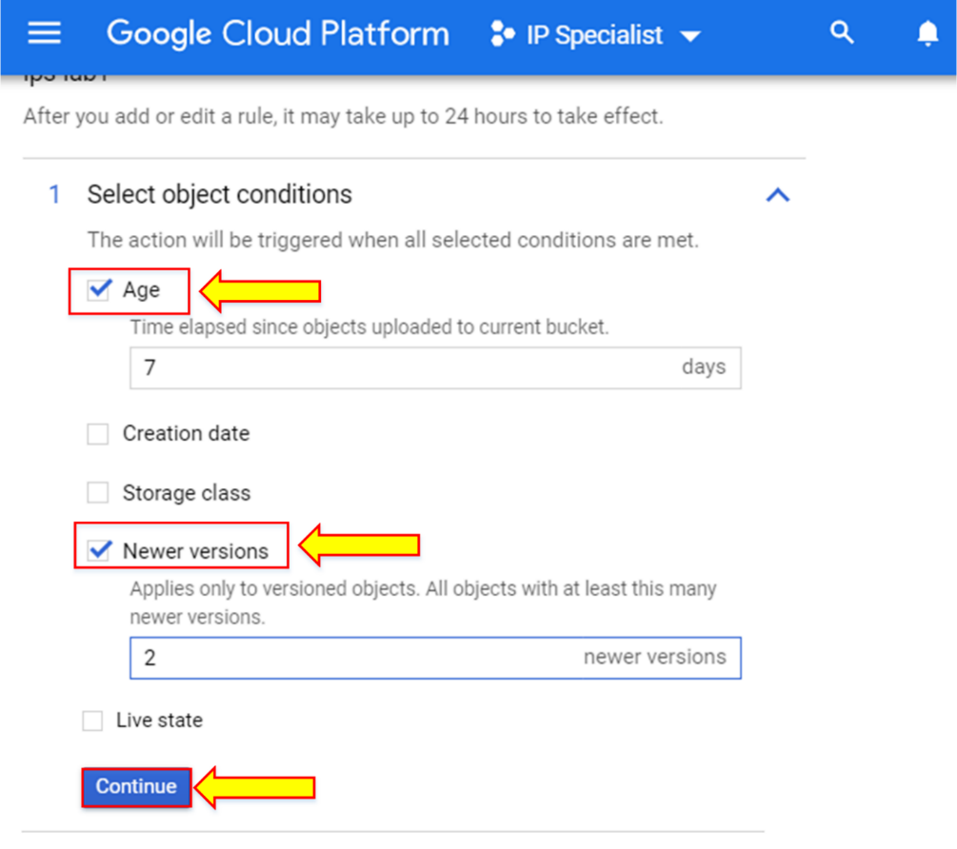

1. Select the action and click “Continue”. Then click “Save”.

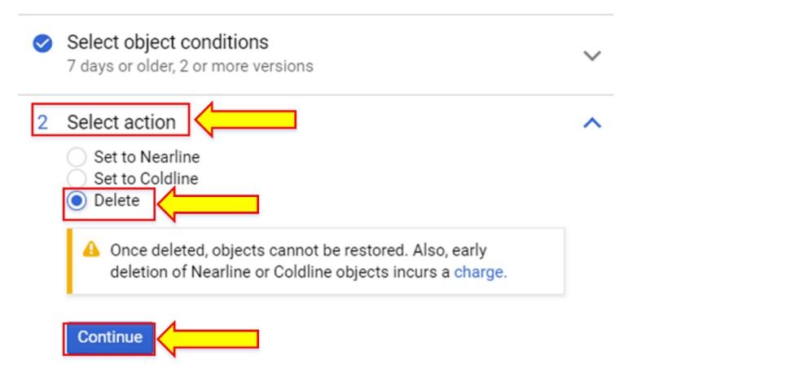

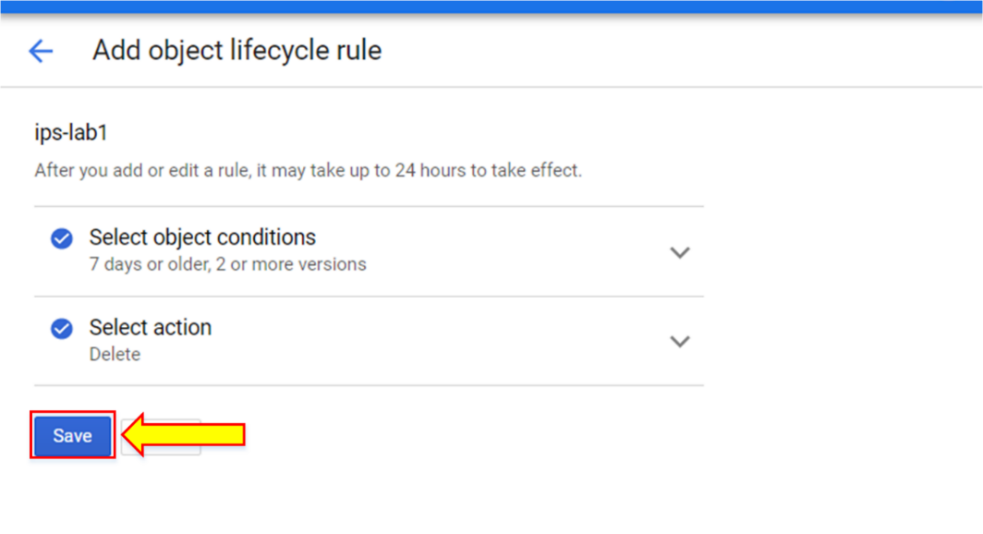

1. The result of lifecycle management rules is not immediately applied; this can take hours.
2. You can do the lifecycle management via Cloud Shell by typing the command “gsutil lifecycle get gs://<bucketname> > <filename.json>”.

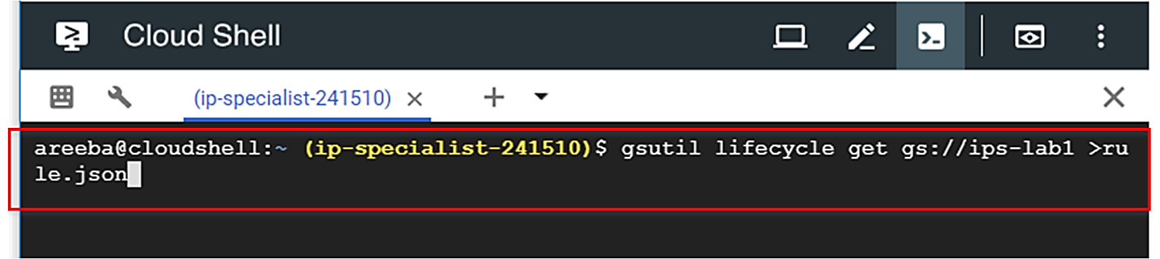

1. Now the file is in the directory. Go into the file, edit it, and then save it. For example, here we changed the age to 5 days.

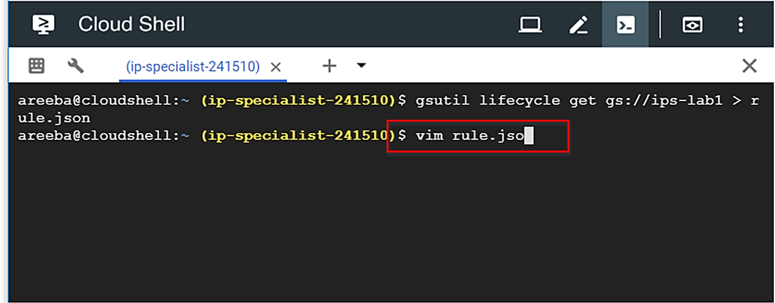

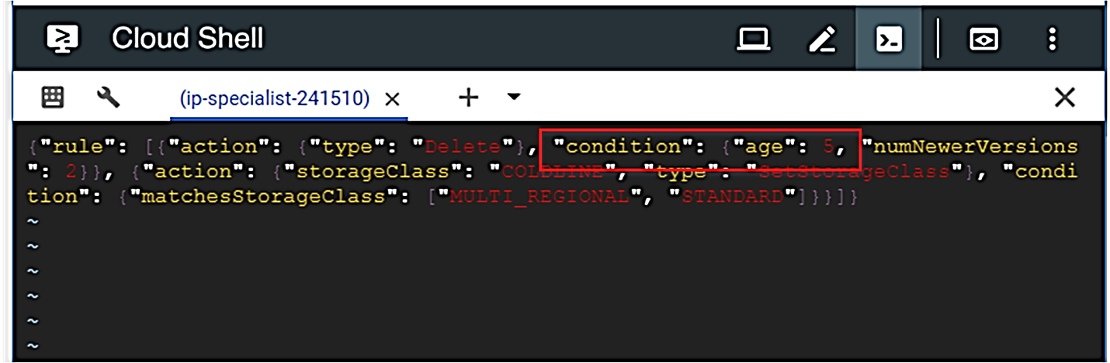

1. Now, set this new lifecycle policy by typing the command “gsutil lifecycle set <filename.json> gs://<bucketname>”.

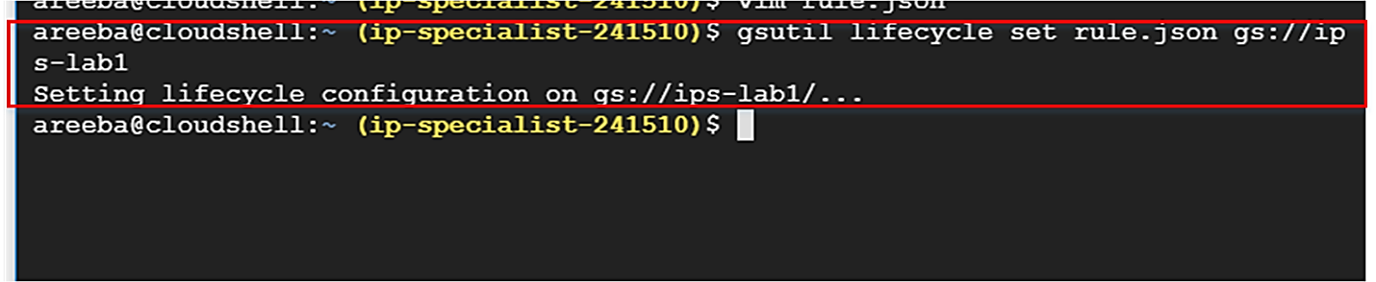

1. After that, go to the GCP console and refresh the page. You can see that now the age condition has changed to 5.

